Ryan Baber Assignment 5.2 9/13/26
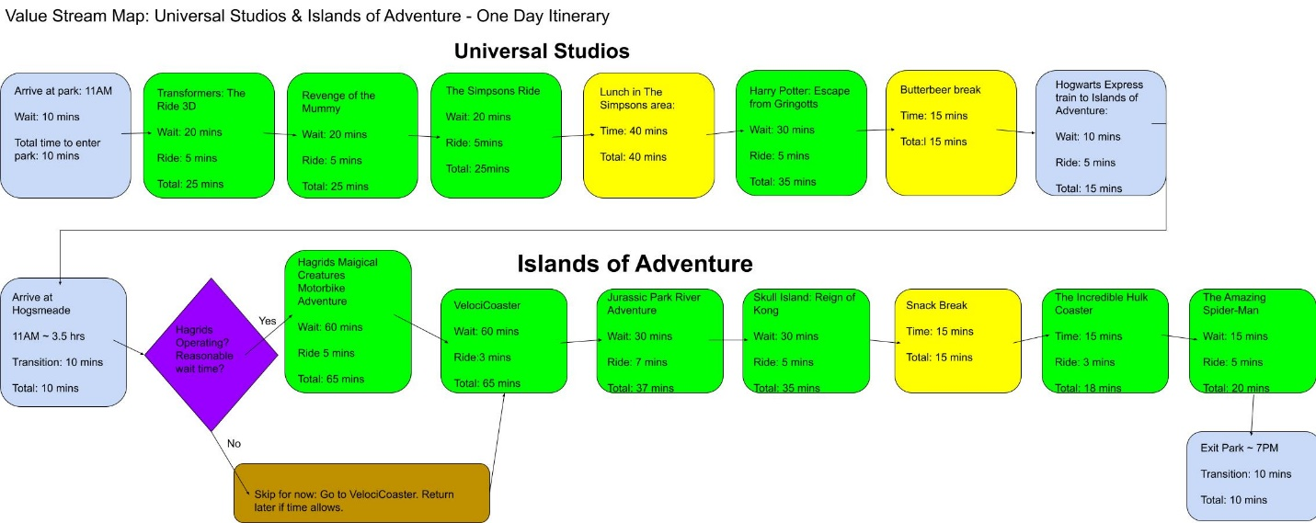

Goal and Scenario
The goal of this VSM is to plan an efficient and successful way to experience the major rides and attractions at Universal Studios Florida and Islands of Adventure, all in one day. The group will arrive at Universal Studios at around 11 AM and plans to leave Islands of Adventure around 7 PM. The group will not use single-rider lines, since they all want to be together for the rides. The estimated wait times represent the wait times for the stander lines. Lunch and snack breaks are included during the day, and the group will eat dinner at CityWalk after leaving the parks.
Lean Metrics and Analysis
Most of the time in this process is spent waiting in line at attractions. Most rides have estimated wait times between 15 and 30 minutes, while Hagrid’s Magical Creature Motorbike Adventure and VelociCoaster can have wait times of approximately 60 minutes. These two attractions are the largest bottlenecks in the value stream. Other non-value-added time can include unnecessary walking, backtracking, attraction delays, and waiting for food.
Optimization
The route is designed to reduce unnecessary walking by completing attractions in a logical order through Universal Studios before taking the Hogwarts Express to Islands of Adventure. Lunch is planned for after The Simpsons Ride, since the area offers a variety of food options. The Butterbeer break will happen before leaving for Islands of Adventure. Hagrid’s is treated as a decision point because it frequently experiences long waits or delays. If the wait is unreasonable, the group can continue to VelociCoaster and return to Hagrid’s later. This prevents one attraction from delaying the entire schedule.
Conclusion
Using a planned route makes it possible to experience the major attractions at both parks without rushing through the day. Lower wait times also provide extra time for breaks and possibly for repeat visits to attractions. The value stream map shows how planning the order of activities, identifying bottlenecks, and remaining flexible can make the overall experience more efficient.

